Notes on Intermolecular Forces
So far, we’ve been talking about intRAmolecular forces, or forces between atoms (withIN a molecule). These forces are referred to as bonds. We have studied three types of bonds: ionic, covalent (both polar and nonpolar) and metallic. Write down everything you know about these types of bonds on your yellow graphic organizer. Include examples of each type of bond.

Now we’re going to talk about forces between covalent molecules. Note: we are only talking about covalent molecules here. These are nonbonding, or intERmolecular forces. These are the forces that must be over come when converting a solid to a liquid and a liquid to a gas. Remember, it takes energy to boil something. Well, what is that energy being used to do? It is breaking the forces between the molecules and allowing them to separate. The stronger the intERmolecular forces, the harder it is to melt or boil (meaning you have to add more energy).
Three types of force can operate between covalent molecules:
- Dispersion Forces, also known as London Forces or van der Waals forces
- Dipole-dipole interactions
- Hydrogen forces (sometimes called hydrogen bonds, but we do not like that word because IT IS NOT A BOND, IT IS A FORCE!!!)

Dispersion Forces (London Forces, van der Waal's Forces)

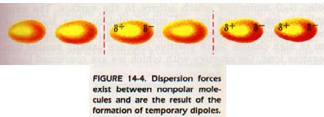
Every molecule has dispersion forces. Dispersion forces are very, very weak. They exist because every once in a while for a teeny tiny split second, more electrons end up on one side of a molecule than another. (Remember, a molecule has one giant electron cloud shared by all of the atoms and the electrons might be spread out unevenly for a split instant.) During this teeny tiny split second the molecule has an ity bity negative end and an ity bity positive end. This is called an instantaneous dipole. These ity bity poles are not as strong as permanent dipoles or ions but they are strong enough that the negative end of one molecule can attract the positive end of another molecule for a split second.

- The more electrons that are present in the molecule, the stronger the dispersion forces will be.
- Dispersion forces are the only type of intermolecular force operating between non-polar molecules, for example, dispersion forces operate between hydrogen (H₂) molecules, chlorine (Cl₂) molecules, carbon dioxide (CO₂) molecules, dinitrogen tetroxide (N₂O₄) molecules and methane (CH₄) molecules.

Dipole-dipole Interactions
- are stronger intermolecular forces than Dispersion forces
- occur between molecules that have permanent dipoles (polar molecules), for example, dipole-dipole interactions occur between SCl₂ molecules, PCl₃ molecules and CH₃Cl molecules.
If the permanent net dipole within the polar molecules results from a covalent bond between a hydrogen atom and either fluorine, oxygen or nitrogen, the resulting intermolecular force is referred to as a hydrogen bond (see below).
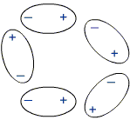
- The partial positive charge on one molecule is electrostatically attracted to the partial negative charge on a neighboring molecule.

Hydrogen forces

Hydrogen forces are just like dipole-dipole interactions but they are REALLY STRONG. They occur when a molecule has a hydrogen bonded to a fluorine, oxygen, or nitrogen (hydrogen bonding is FON). The electronegativity difference between hydrogen and these three atoms is very large so the dipole is REALLY strong. Note: the hydrogen and the F,O, or N have to be bonded to each other in the same molecule to allow for hydrogen forces to exist
- Hydrogen forces operate between water (H₂O) molecules, ammonia (NH₃) molecules, hydrogen fluoride (HF) molecules, hydrogen peroxide (H₂O₂) molecules, methanol (CH₃OH) molecules, and methyl amine, (CH₃NH₂) molecules.
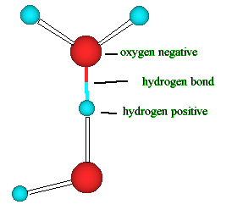
- Hydrogen forces are a stronger intermolecular force than either Dispersion forces or dipole-dipole interactions.
Relative strength of Intermolecular Forces
- Intermolecular forces (dispersion forces, dipole-dipole interactions and hydrogen bonds) are much weaker than intramolecular forces (covalent bonds, ionic bonds or metallic bonds)
- dispersion forces are the weakest intermolecular force (one hundredth-one thousandth the strength of a covalent bond), hydrogen bonds are the strongest intermolecular force (about one-tenth the strength of a covalent bond).
- dispersion forces < dipole-dipole interactions < hydrogen bonds

Surface Tension

When you try to see how many drops of water will fit on a penny, what happens? You can fit a lot of drops on the penny and the water forms a bubble on the surface of the penny. This bubble is a result of surface tension. Water has a very high surface tension because it has strong hydrogen forces. These hydrogen forces hold the water molecules together so tightly that it is hard for gravity to pull them apart. (Although, eventually gravity wins and the bubble spills). Anything with strong intermolecular forces will have a relatively high surface tension. Water’s surface tension is especially strong because water is such a polar molecule and has strong hydrogen forces between molecules. Soap can be used to break the surface tension of water. Soap is a big molecule with a nonpolar end and a polar end and it can be used to get two things like oil and water to mix. That’s why when you wash your hair without shampoo it still feels greasy. You have to use shampoo to get the nonpolar grease to mix with the water to wash out.

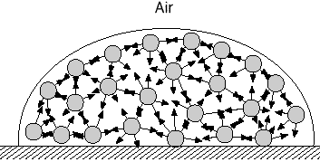

Summary

Force |  | Strength | Types of molecules
Dispersion | Temporary dipole | Very weak | Between all types of molecules
Dipole-Dipole | Permanent dipole | Medium | between 2+ polar molecules
Hydrogen force | Strong permanent dipole | Strong | When H is bonded to F,O, or N

Solving Problems

- Which boils at a higher temperature?
To answer this question, look at your choices and find the one with the strongest intermolecular forces. (remember, an ionic molecule beats them all). The one with the strongest intermolecular forces takes more energy to break apart/boil.

EX: CH₄ has a lower boiling point than CH₃F because CH₄ only has dispersion forces but CH₃F has dipole-dipole forces as well as dispersion. (note: draw the structure of CH₃F- it does not have hydrogen forces because the H and F are not bonded.)

EX: I₂ has a higher boiling point than Cl₂ because although they both only have dispersion forces (they are both nonpolar) I₂ is a bigger molecule and has more electrons so it has stronger dispersion forces. P.S. this is why chlorine is a gas at room temperature and iodine is a solid.

EX: NH₃ has a higher boiling point than NF₃ because NH₃ can have hydrogen forces between molecules whereas NF₃ can only have dipole-dipole interactions.

EX: CaBr₂ has a higher boiling point than H₂O because it is an ionic molecule. Ionic molecules almost always have a higher boiling point because they have ion-ion interactions which are stronger than hydrogen forces in water and other intermolecular forces.

- What forces are present?
To answer this question, determine what the polarity of the molecule is and refer to the chart above. You will probably have to draw the structure, especially to determine if hydrogen forces are present.

EX: CH₄- this is a nonpolar molecule so the only forces that can be present are dispersion forces.

EX: HBr- this is a polar molecule so dispersion forces and dipole-dipole interactions are present.

EX: NH₃- this is a polar molecule with an N bonded to an H. This means that hydrogen forces are present along with dispersion forces.

